MODEL VALIDATION
THIS MODEL VALIDATION ONLY FOR SIMPLE MODEL, FOR COMPLEX USE FLUENT VALIDATION
- Let say we want to validate the model of post method. Then open CreateRestaurantsDto.cs to add model validation there.
- Add validation like email address, phone, required field and regex expression and make sure give the error message if user enter the wrong format
- Example of bad data
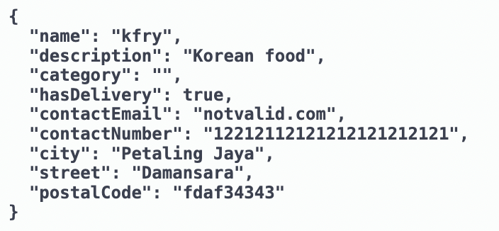
- Example of error message will appear
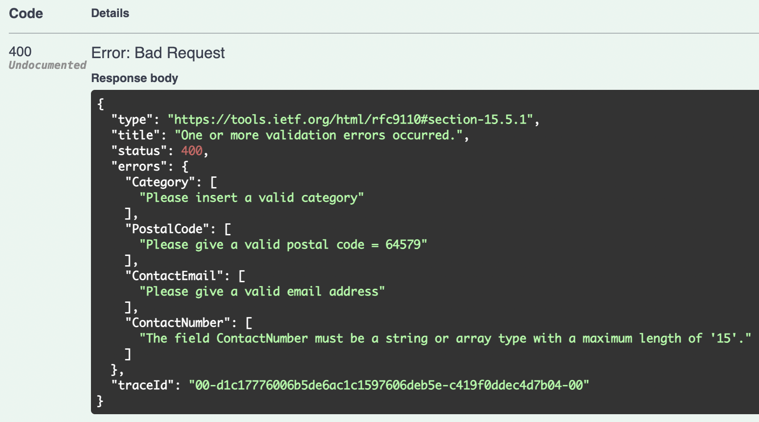
- Example of good data
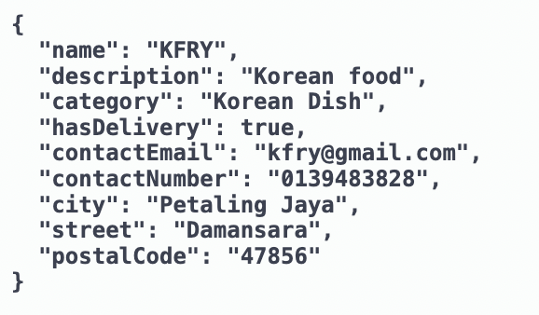
- Example results:
